**Q-1. Write an SQL query to fetch “FIRST_NAME” from Worker table using the alias name as <WORKER_NAME>.**

**ANWER :**

SELECT first_name AS WORKER_NAME

FROM worker

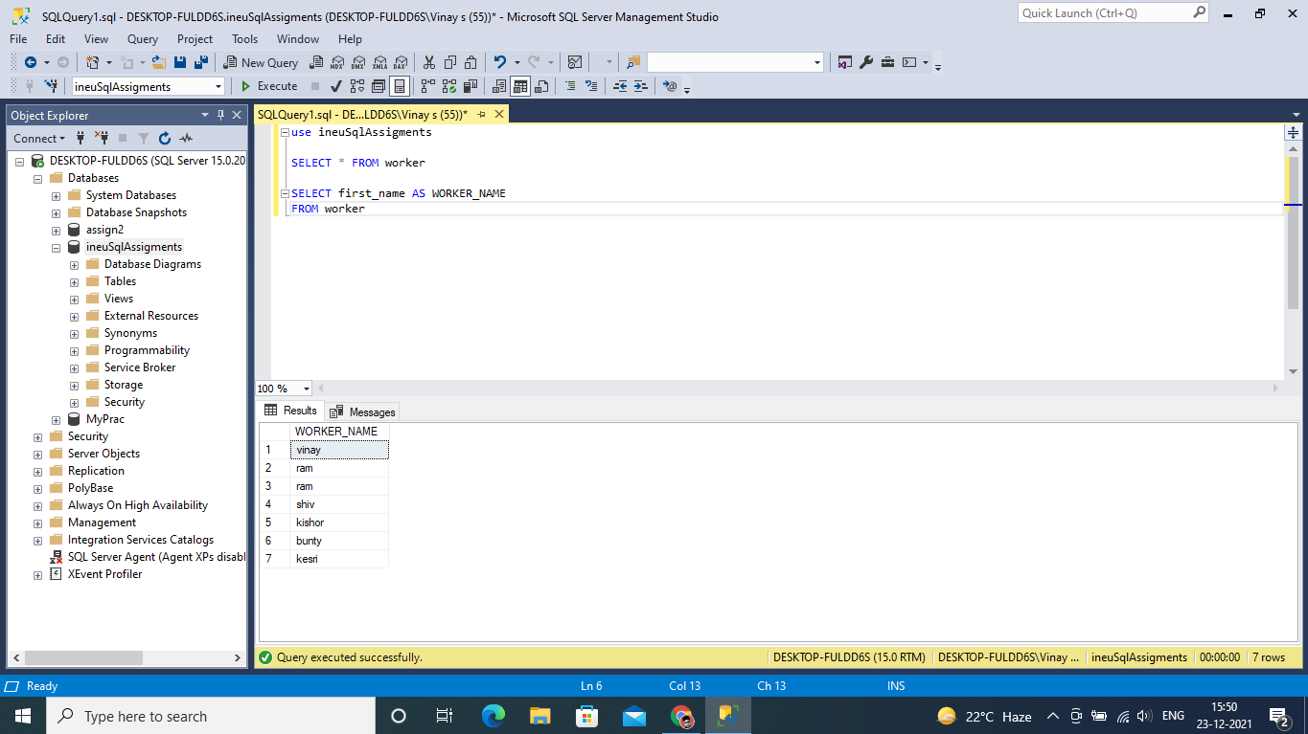

#### Q-2. Write an SQL query to fetch unique values of DEPARTMENT from Worker table.

**ANSWER :**

SELECT DISTINCT DEPARTMENT

FROM worker

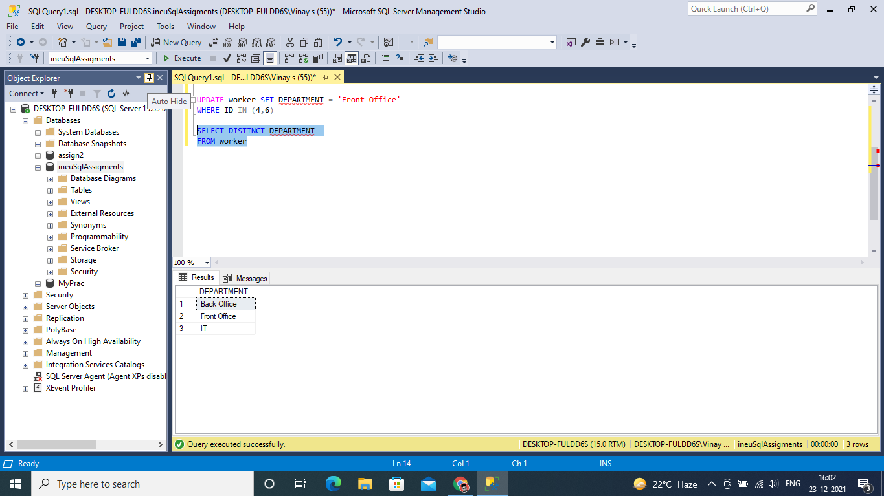

#### Q-3. Write an SQL query to show the last 5 record from a table.

**ANSWER :**

SELECT TOP 5 *

FROM worker

ORDER BY ID DESC

